3161 43rd St S • Fargo, ND 58104
Phone: (701) 893-2639
Fax: (701) 893-2638
www.bodyworksfargo.com
MASSAGE THERAPY
REGISTRATION & RELEASE FORM

Client Name: (print) Date of Birth: Age:
First Name, MI, Last Name
Responsible Party: (if minor) Relationship:

Address: City: State: _____ Zip:

Cell Phone: ( ) Home Phone: ( )

E-mail Address: Occupation:

Emergency Contact: Relationship:

Emergency Contact Phone: ( ) Alternate Phone: ( )

Reason for Visit: Referred By:

Please take a moment to carefully read the following information and sign where indicated.

 I understand that this information will be treated confidentially.
 In order to maximize the effectiveness and safety of massage sessions, I agree to give feedback during and at the end of my sessions.
 I understand that I will need to update my therapist on my health and wellness prior to each session.
 I understand that the massage/bodywork I receive is provided for the relief of muscular tension and soreness. If I experience any pain or discomfort during this session, I will immediately inform the therapist.
 I further understand that massage/bodywork should not be construed as a substitute for a medical examination, diagnosis, or treatment and that I should see a qualified medical specialist for any physical or mental ailment of which I am aware.
 I understand that massage therapists/bodyworkers are not qualified to perform spinal or skeletal adjustments, diagnose, prescribe, or treat any physical or emotional conditions and that nothing said during the course of treatment should be construed as such.
 I understand that payment is due in full after my massage and cannot be billed to me or my insurance.
 I understand, as a courtesy, that I need to give a 24-hour notice if I am unable to make it to my appointment.
 I affirm that I have stated all of my known medical conditions and have answered all questions honestly. I understand that there shall be no liability on the practitioner’s part should I forget to do so.
Due to HIPAA and confidentiality requirements, we must ask the following questions.
Please read and check the appropriate places.

It is okay to speak with or leave messages regarding my appointments with anyone at/on my (check all that apply):
____ Home ____ Work ____ Answering Machine ____ Voice Mail ____ E-mail ____ Facebook

Is there anyone that you do not want us to leave a message with regarding appointments?
____ No ____ Yes, Please List:

It is okay to discuss any medical, scheduling and/or billing information with the following people:

PRINT NAME SIGNATURE DATE

3161 43rd St S • Fargo, ND 58104
Phone: (701) 893-2639
Fax: (701) 893-2638
www.bodyworksfargo.com
MASSAGE THERAPY
HEALTH & WELLNESS FORM

Please review this list and check any illness and/or medical conditions which apply currently or in the last five years.

❑ Acne  Dizziness/Fainting  Osteoporosis
❑ Allergies  Edema  Pregnancy – what trimester?
❑ Arthritis  Fibromyalgia  Ruptured/Bulging Disc – where?
❑ Back Pain  Frequent Headaches  Seizures
❑ Bruise Easily  Heart Condition  Skin Rashes
❑ Cancer or Tumors – what type?____________________________is it in remission? _______  Stroke – date(s)?
❑ Carpal Tunnel  High Blood Pressure  Thyroid Disorder (hypo – hyper)
❑ Chronic Fatigue  Infectious Conditions  TMJ Disorder
❑ Constipation  Insomnia  Varicose Veins or Blood Clots
❑ Diabetes – what type?___________  Kidney Disorders  Other:
❑ Digestive Problems  Low Blood Pressure

Do you wear:    Hearing Aids  Contact Lenses  Dentures  Pacemaker

List any injuries not requiring surgery that occurred within the past 2 years (broken bones, torn ligaments, auto accident, etc.)

List all medications you currently take (include over the counter medications as well as vitamins/herbs)

Are you sensitive to touch in any areas?  YES  NO If yes, please list:
What type(s) of exercise do you engage in regularly?

Is stress affecting your health and wellness?  YES  NO If yes, please describe:
Circle the number which best describes your current level of stress: Circle the number which best describes your current level of health:
(Low) 0 1 2 3 4 5 (High) (Low) 0 1 2 3 4 5 (High)
Is one of your goals in receiving massage to reduce the adverse affects of stress?  YES  NO
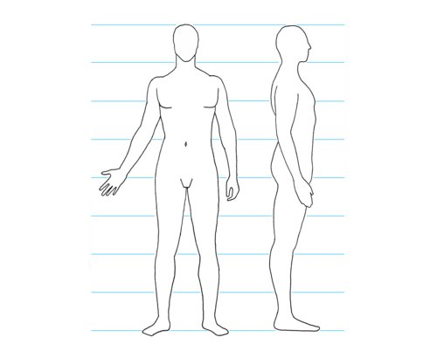
Back
L
R
Front

PRINT NAME SIGNATURE DATE

If you are having problems in specific body areas, mark them on the diagrams to the right with the following indications:

N = numbness
T = tingling
ST = stiffness
S = soreness
P = pain
A = ache

What is your primary complaint? ___________
______________________________________
______________________________________

